**Modeling the hydrologic effects of large-scale green roof implementations in four urban watersheds in Seattle, Washington using a spatially explicit ecohydrological watershed model**

Brad Barnhart1, Paul Pettus1, Robert McKane1, Jonathan Halama1, Paul Mayer1, Allen Brookes1, Kevin Djang2, M. Monika Moskal3

1U.S. Environmental Protection Agency, Corvallis, OR

2CSRA, Corvallis

3University of Washington, Seattle, WA.

**Abstract**

We utilize a spatially explicit (i.e., gridded) ecohydrological watershed model called Visualizing Ecosystem Land Management Assessments (VELMA) to simulate watershed-scale hydrologic discharge for four urban watersheds in Seattle, Washington: Thornton Creek, Piper’s Creek, Longfellow Creek, and Taylor Creek. 1-m land use classification is used to distinguish four cover types, including roads, buildings, trees, and grass. We then test several scenarios of hypothetical green roof implementations (i.e., 25%, 50%, 75%, and 100% of existing buildings converted to green roofs) and simulate their impacts on watershed-scale discharge compared to baseline simulations. Intensive and extensive green roof scenarios were tested separately and resulted in approximately 30% and 15% annual flow volume reductions, respectively. VELMA uses a daily time step, and no lags were observed between the scenarios and baseline hydrologic discharge simulations; this suggests that if green roofs delay runoff during and after storm events, the delay durations are ≤1 day. We also show that stormwater runoff reductions are smaller at higher precipitation and flow regimes, likely due to the limited storage capacity of saturated green roofs. In general, the results suggest that wide-scale implementation of green roofs can be effective at reducing stormwater runoff. Also, grid-based watershed models can facilitate the prioritization of urban water infrastructure to improve water quality in urban streams leading to Puget Sound.

Keywords: Green roofs, urban watershed modeling, VELMA, stormwater

**1. Introduction**

Watershed models have been widely used to simulate the combined effects of topography, soil type, land use, and management on water quantity and quality. In particular, numerous studies have examined the impacts of alternative land use scenarios on various hydrologic and biogeochemical components throughout urban, suburban, rural as well as mixed-use regions (CITE A REVIEW PAPER). Mechanistic or processed-based watershed models typically represent the environmental system as a series of equations that replicates the dynamics of the system. Temporally, these models vary from hours (CITE SWAT SWMM) to decades (CITE VELMA, SWAT), and spatially, they are generally classified as either semi-distributed—that is, models that utilize subbasins (e.g., HSPF, SWAT, XX)—or spatially explicit, which simulate interrelated voxels within a gridded matrix (e.g., VELMA, DHSVM). XXXXX Tie this up somehow.

In Seattle, Washington as well as throughout the United States (CITE) and the world (CITE), green infrastructure has gained attention as an urban management option that can potentially reduce and delay storm runoff and provide a host of other ecosystem services, including EXAMPLES CITE CITE. The term ‘green infrastructure’ typically includes a suite of practices that can be installed and implemented in urban and/or semi-urban systems, including green roofs (CITE), permeable pavement (CITE), bioswales (CITE), and riparian buffers (CITE), among others. Green roofs, in particular, are among the most popular green infrastructure implemented in highly urbanized watersheds due to their low cost and efficient utilization of unused or under-used space (Carter and Jackson 2007; CITE BOLLMAN paper).

Green roofs are generally categorized as either intensive or extensive. Intensive green roofs (IGRs) are characterized by thicker soil columns (6-36”; CITE SURVEY) and larger vegetation and can include landscaped gardens, mixtures of trees, bushes, XXX. They require substantial structural support and are typically installed on larger, commercial buildings that may allow pedestrian access. Extensive green roofs (EGRs) are characterized by shallow soil depths (2-6”; CITE SURVEY) and low-level vegetation that typically covers a large proportion of the roof. EGRs can be implemented on buildings with less structural support than IGRs, and they typically do not require maintenance such as irrigation, fertilization.

Recently, there has been a renewed interest in evaluating the potential for green roof implementations to mitigate and retain peak storm runoff in urban watersheds. For example, XXX ( )

Taken together, these studies suggest that peak storm runoff can be reduced from X% - Y%. In addition, retention times are on the order of minutes to hours and can help to slow stormflow. Still, further research is needed to estimate the impact of potential green infrastructure implementations in the Pacific Northwest, USA. In addition, spatially explicit models can serve to place potential infrastructure implementations in exact locations in urban watersheds. Therefore, development is needed to XXXXX.

In this paper, we model watershed-scale hydrologic discharge for four urban watersheds in Seattle, Washington. We use a spatially explicit (i.e., gridded) watershed model to explicitly account for spatially distributed urbanized land cover—in particular, a 1-m land use/ land cover (LULC) data layer (resampled to 10 m) differentiates buildings, roads and other impermeable surfaces (e.g., parking lots, sidewalks), trees, and grass. After initial calibration and validation with observed hydrologic discharge data at the watersheds’ outlets, we construct four scenarios of varying levels of green roof implementations that randomly distribute green roof parameterizations to existing buildings in each of the watersheds (i.e., 25%, 50%, 75%, 100%). We run two sets of scenarios to test the effects of installing intensive vs. extensive green roofs and compare the resulting hydrologic discharge with the baseline simulations.

Using this methodology, the study will provide two major contributions. First, until now, green roofs have not been incorporated within the VELMA watershed model. Therefore, our parameterizations and model improvements will be useful for future studies that seek to use VELMA or similar watershed models to simulate the impacts of green roofs, perhaps among other green and traditional infrastructure development, on discharge and peak stormflow in other watersheds. Second, by testing scenarios of green roof implementations in four urban watersheds in Seattle, Washington, our results will provide estimates for the amount of green roof areal implementations that are needed to achieve various reductions in peak stormflow. By simulating the impacts of converting every roof in the watershed to a green roof (100% implementation), we provide an upper limit on the possible peak stormflow reductions that can be expected for these Seattle watersheds. Coupled with economic estimates for implementation costs, these results can inform decision makers when crafting programs to support the adoption of urban green infrastructure including green roofs.

**2. Methodology**

**2.1. Study Areas**

We focus on four watersheds in the four corners of the Seattle, Washington metropolitan area: Thornton Creek, Piper’s Creek, Longfellow Creek, and Taylor Creek. Figure 1 shows Seattle, Washington and the four watershed areas along with their respective stream networks. Note that two of the watersheds drain into Puget Sound to the west, and two drain into Lake Washington to the east. These watersheds were selected because they represent well-sampled and studied watersheds and are also located in the four corners of the Seattle metropolitan area.

**<INSERT FIGURE 1 HERE>**

Figure 1. The four watersheds in Seattle, Washington examined in this study.

Table 1 shows the percentage distribution of land use for each of the four watersheds, as derived from the 1-m land use/ land cover data obtained from XXXX. This data is described further in the Input Data section.

|  |  |  |  |  |
| --- | --- | --- | --- | --- |
| **Table 1.** Within-watershed land use classification percentages. | | | | |
|
|  | **Longfellow** | **Pipers** | **Taylor** | **Thornton** |
| Buildings | 10% | 11% | 10% | 10% |
| Impervious Surfaces (e.g., Roads, Parking Lots, Sidewalks) | 31% | 24% | 24% | 26% |
| Trees | 34% | 46% | 42% | 42% |
| Grass | 25% | 19% | 24% | 22% |
| Watershed Area | 11 km2 | 6.5 km2 | 3 km2 | 31 km2 |

Note that the four watersheds vary in size from approximately 3 km2 to 31 km2, yet the land use classification characteristics are remarkably similar. These data may be useful for comparison with other urbanized areas throughout the United States and the world.

Longfellow Creek is located in the southwestern corner of Seattle, Washington and represents the highest urbanized watershed among the four based on its percentage of buildings and impervious surfaces (e.g., roads, parking lots, and sidewalks). The High Point neighborhood accounts for approximately 10% of the Longfellow Creek watershed, and this neighborhood has worked with Seattle Public Utilities since the 1980s to adopt green infrastructure practices such as grass and vegetated swales, porous pavement, and a large storm-water pond to slow runoff and filter contaminants before reaching the creek and ultimately heading to the Puget Sound (Seattle Public Utilities, 2018).

Thornton Creek is located in the northeastern corner of Seattle, Washington and represents the largest watershed in our sample (31 km2). The watershed is heavily urbanized including the crossing of the N-S-bound Interstate 5, which cuts through the western portion of the watershed. Numerous have green infrastructure and low-impact design studies have been implemented in Thornton Creek, including the widely known Thornton Creek Water Quality Channel (US EPA, 2018). Approximately 10% of the watershed’s area includes buildings that will be hypothetically converted to green roofs in this study.

Pipers Creek is located on the western side of Seattle, Washington and flows directly into Puget Sound. The watershed holds the highest percentage of forests of all the watersheds (46%) in our sample. However, approximately 11% of the watershed area can be attributed to buildings.

Taylor Creek is located in the southeastern region of Seattle, Washington and flows into Lake Washington. Taylor is the smallest watershed in our sample (3 km2), and the total areal percentage of buildings within the watershed is 10%. While restoration efforts led by the Seattle Public Utilities have been conducted throughout the watershed since 1971 (CITE), the large-scale potential of green roof implementations have not been investigated.

These four watersheds were chosen for our sample because they represent varying sizes of watersheds in each of the four corners of Seattle, Washington. Also, the input data required to run the watershed model, which will be described in a subsequent section, were available for each of these watersheds.

**2.2. Watershed Model**

**2.2.1. *Model Overview***

To simulate the effects of varying green roof implementation scenarios on hydrologic discharge, we used the Visualizing Ecosystem and Land Management Assessments (VELMA) model. VELMA is a spatially explicit (i.e., gridded) watershed model that integrates hydrologic and biogeochemical (C and N) sub-models to simulate numerous environmental attributes, including watershed-scale discharge (CITE Abdelnour). A complete description of the model and its sub-components can be found in the Abdelnour (CITE) and the VELMA user manual (CITE USER MANUAL). The model has been extensively used in a variety of watersheds throughout the world, including grassland prairie ecosystems (CITE), forests in the Pacific Northwest (abdelnour, etc.), arctic tundra (CITE), and mixed-use ecosystems (NAHAL).

**2.2.2. *Model Improvements***

VELMA has only recently been used to model semi-urbanized environments (CITE NAHAL) and has not yet been used in fully urbanized watersheds. Also, until now, the model has not explicitly modeled green roofs. Figure X depicts a single VELMA voxel that describes how VELMA models the environment. The left panel designates a traditional VELMA voxel (after Abdelnour 2011). Nahal et al. (CITE) introduced an impermeable layer that limited the percentage of water that could infiltrate from the surface to the first soil layer. This improvement allows VELMA to simulate increased surface runoff and less infiltration caused by the increased impermeability of urbanized surfaces (e.g., buildings, roads, parking lots, sidewalks).

In addition to utilizing this previous improvement to better represent urbanized surfaces, we made model modifications for VELMA to represent green roofs. Figure XX shows how the traditional VELMA voxel representation (Figure XX, left panel) was altered to accommodate green roofs (Figure XX, right panel). First, an impermeable boundary is placed between the first layer and the second layer. Above this boundary, the first layer is characterized by the soil properties of the green roof. In practice, the vertical saturated hydraulic conductivity (Ks) is changed to a small non-zero value to limit flow from the first layer (considered to be on top of the building) to the underlying soil layers (below the building). Lateral flow is allowed both out of the first soil layer (i.e., the green roof) and in and out of the lower soil layers.

Figure 2. A single VELMA voxel depicting lateral and vertical flows. The left panel is a standard VELMA setup, and the right panel is the changed voxel structure to represent green roofs.

Layer 2

Layer 3

Layer 4

Green Roof

Impermeable Layer

Boundary

Layer 2

Layer 3

Layer 4

Layer 1

Boundary

Optional Impermeable Layer

Land cover and soil parameterizations for green roof voxels are also changed and will be described in the Green Roof Scenarios section.

**2.3. Input Data**

A number of standard, spatially distributed inputs are required to construct watershed models including VELMA. These include a digital elevation model, soil and land use/land cover maps, a stream network, and weather drivers including daily temperature and precipitation, all of which are summarized in Table 2.

A 10-m digital elevation model was acquired from the USGS (Table 2) via . This initial layer was processed using the JPDEM processing tool (CITE via Nahal’s paper). A hand-digitized stream network obtained from the City of Seattle was used to aid the processing tool in order to correctly route flow in a pre-determined manner.

Soils data was obtained from XXX

Custom derived land use data were acquired from the City of Seattle (Table 2). <INSERT DESCRIPTION OF LAND USE/LAND COVER CLASSIFICATION SCHEME>>> Theses 1m land use land cover data (Table 1) were then resampled to 10m cells via majority rule, resulting in an average increase of 0.58% in building area for the four watersheds. For these and other geospatial and statistical techniques used in this analysis, scripts were written using R 3.1.2 statistical software (R Core Team, 2012) and Python 2.7.12 (Python Software Foundation, 2016) programming language. Visualizations, sampling location analysis, and basic map editing were made with ArcGIS 10.3 (ESRI, 2014).

Three NOAA-referenced weather stations (i.e., Sand Point, Portage Bay, and Boeing Field) and Daymet modeled data were used to compile daily mean temperature and precipitation estimates for the duration of our model runs (NOAA, 2016; Thornton et al., 2016). All three stations were within the Seattle city limits and were located between 2-21.5 km of either Thornton or Pipers creeks. The Sand Point weather station had 10,076 recorded daily weather observations between 1/1/1986 and 12/31/2015. During this time period, Sand Point had 526 missing daily observations, 13 precipitation NA’s, and 1 average temperature NA observations. Between 1/1/1986 and 4/30/1998 Sand Point had 151 missing daily observations, 4 precipitation NA’s, and 1 average temperature NA which were gap filled with Portage Bay recorded weather. Boeing Field weather observations were used to gap fill 153 days of missing Sand Point daily data between 12/5/1998 and 12/31/2015, as well as being used to replace the 9 remaining precipitation NA’s. From 5/1/1998 through 12/4/1998 there were no recorded weather observation at Sand Point, Portage Bay, or Boeing Field, so these days were completely gap filled with Daymet modeled data. Daymet model output data were acquired for the 1KM cell at the Sand Point station latitude and longitude. R 3.1.2 statistical software (R Core Team, 2014) was used for gap filling observed NOAA weather station data with Daymet (Thornton et al.,2018) daily gridded modeled weather parameters, using the “daymetr” package (Hufkens et al., 2018) for single cell sampling.

|  |  |  |  |  |  |
| --- | --- | --- | --- | --- | --- |
| **Table 2.** Watershed model input data acquisition and sources. | | | | | |
|
| **Organization** | **Dataset** | **Data type** | **File Format** | **Scale** | **Uncertainty\*** |
| United States Geological Survey (USGS) | National Elevation Dataset | Elevation | Raster | 1/3 arc-second | Z value RMSE = 2.44 m |
| City of Seattle | Urban Streams | Hydrography Dataset | Shapefile | NA | Unknown |
| University of Washington | Land use/land cover (NEED NAME) | Land Cover/Use | Raster | 1 m | ? |
| National Oceanic and Atmospheric Association (NOAA) | Temperature and Precipitation | Daily, Point Location | csv | NA | Unknown |
| ORNL / Daymet | Temperature and Precipitation | Daily, Point Location | csv | NA | Year 2000 Mean Daily Bias: +0.012cm, -0.123 C° |
| United States Department of Agriculture (USDA) | State Soil Geographic data base | Soils | Raster | 10 m | Highly dependent on scale and field methods |

**2.4. Green Roof Scenarios**

As mentioned previously, green roofs are generally categorized as either intensive or extensive, where intensive green roofs (IGRs) are characterized by thicker soil columns (6-36”; CITE SURVEY) and larger vegetation, and extensive green roofs (EGRs) are characterized by shallow soil depths (2-6”; CITE SURVEY) and low-level vegetation. To parameterize green roofs in VELMA, we change both cover and soil characteristics to match those of intensive and extensive green roofs. Table 3 shows the soil characteristic parameterizations for green roofs.

Table 3. Overview of soil characteristics used in the watershed model simulations.

|  |  |  |  |
| --- | --- | --- | --- |
| **Soil Property** | **General** | **Extensive Green Roofs (1st layer)** | **Intensive Green Roofs (1st layer)** |
| Porosity (v/v) | 0.453 | 0.70 | 0.70 |
| Field Capacity (v/v) | 0.207 | 0.60 | 0.65 |
| Wilt Point (v/v) | 0.095 | 0.12 | 0.12 |
| Hydraulic Conductivity (mm/day) | 770 | 87,000 | 10,000 |
| Bulk Density (g/cm3) | 1.52 | 0.50 | 0.75 |
| Depth (mm) | 500 | 100 | 500 |
| pH | 4.5 | 7 | 7 |

The values for the general soil type were chosen to match a sandy loam soil type. The intensive and extensive green roof soil characteristics were taken from the technical specifications of a proprietary source of green roof media (Roof-Lite Extensive 600 Media, Roof-Lite Intensive XXX Media; CITE) that was designated as an approved media source to obtain stormwater reduction credit by the City of Seattle (CITE description).

In addition to the soil characteristics, we also changed the land cover from a traditional building (i.e., no biomass) to cover characteristics of grass that match either extensive or intensive green roofs. VELMA input parameters were manually parameterized to ensure that the simulated maximum annual aboveground biomass values reached approximately 240 and 1000 gCm2yr-1, which match data from experiments conducted by Getter et al. (2009).

Four green roof scenarios were tested using intensive and extensive green roofs separately. Figures 3-6 show the four scenarios for each of the four watersheds.

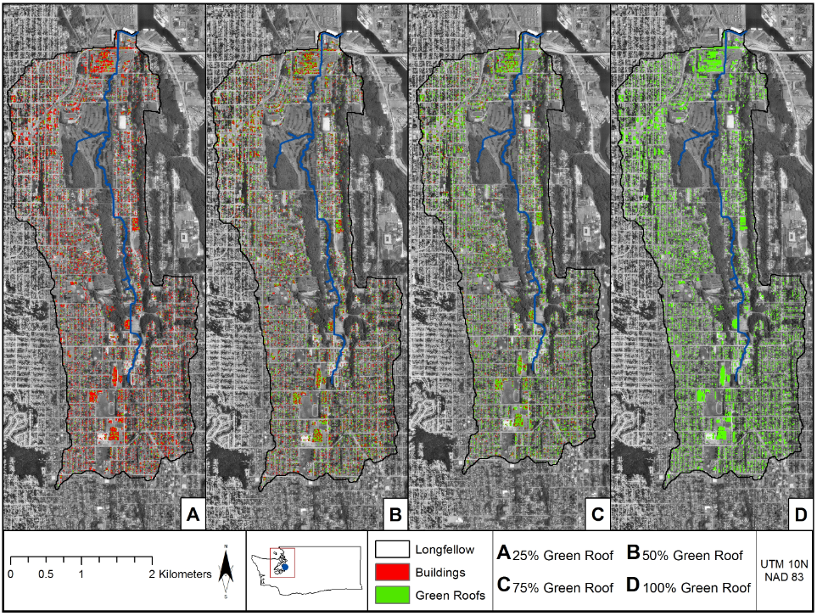

Figure 3. Spatial distribution of green roofs implemented in varying proportions (25%, 50%, 75%, and 100%) of existing buildings within the Longfellow Creek watershed.

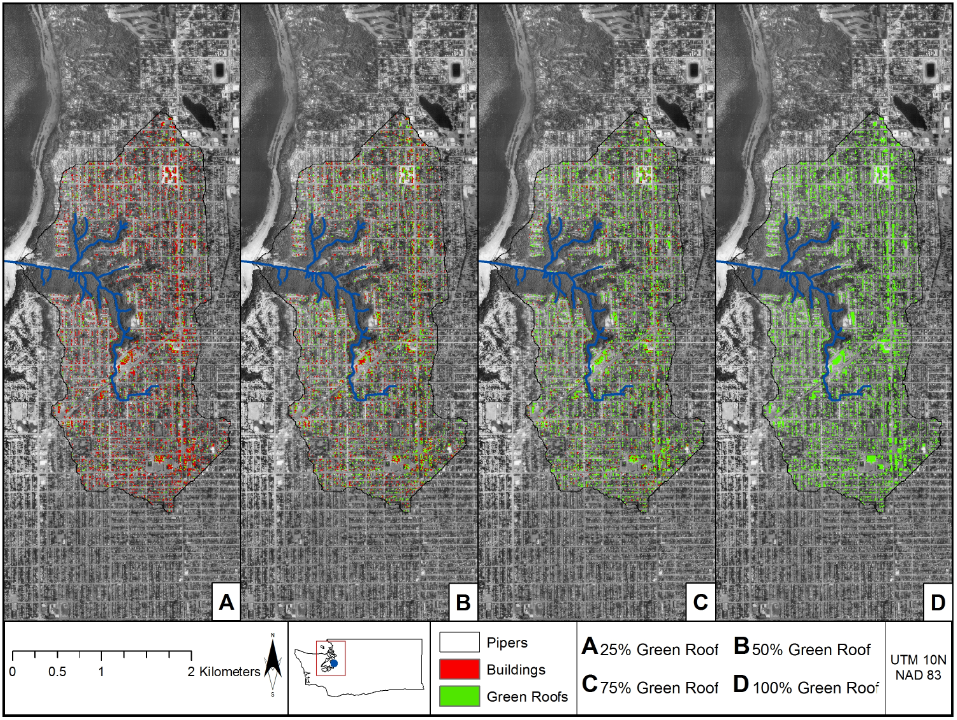

Figure 5. Spatial distribution of green roofs implemented in varying proportions (25%, 50%, 75%, and 100%) of existing buildings within the Pipers Creek watershed.

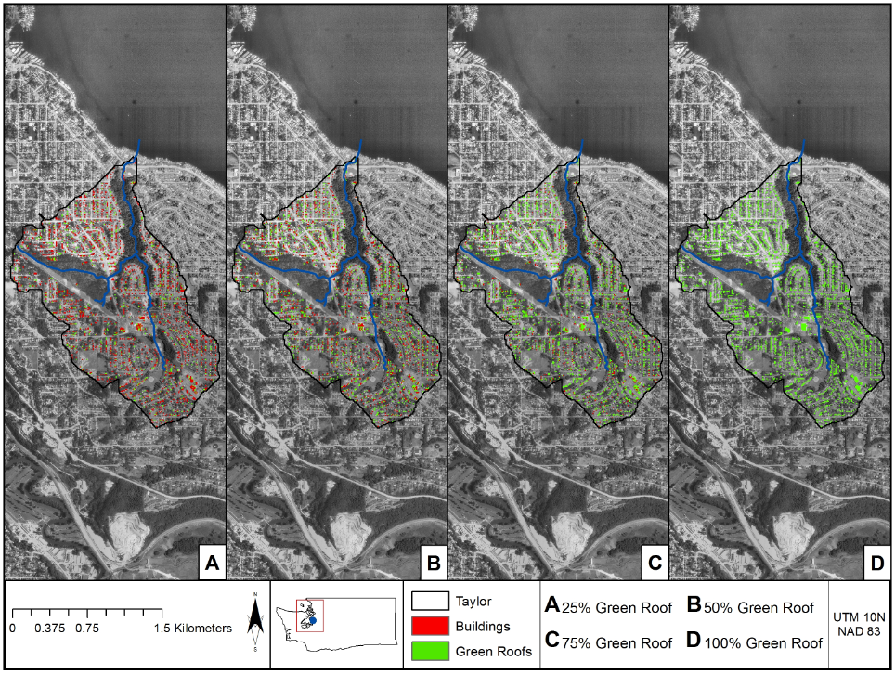

Figure 6. Spatial distribution of green roofs implemented in varying proportions (25%, 50%, 75%, and 100%) of existing buildings within the Taylor Creek watershed.

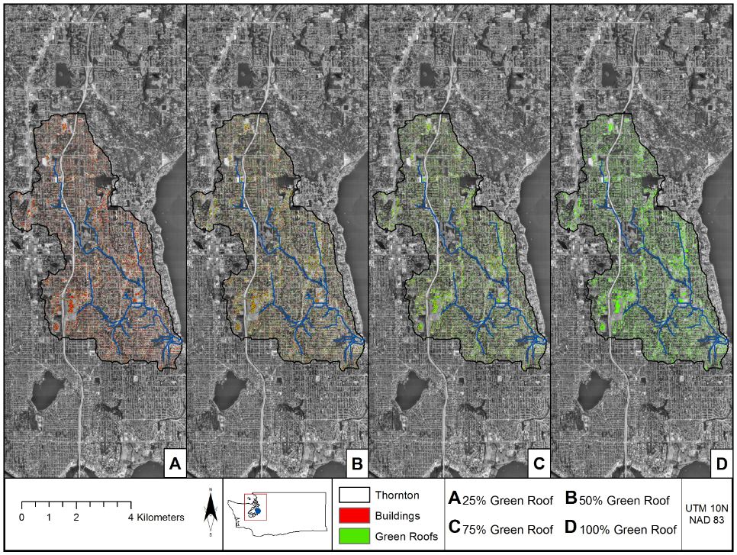

Figure 4. Spatial distribution of green roofs implemented in varying proportions (25%, 50%, 75%, and 100%) of existing buildings within the Thornton Creek watershed.

Each of the four panels in Figures 3-6 show varying proportions of existing buildings converted to green roofs (25%, 50%, 75%, and 100%). The land use types of trees, grass, and roads, parking lots, and sidewalks are all in gray, and the spatial distribution of buildings and green roofs are shown in red and green, respectively. The spatial designations of green roofs were performed randomly.

**2.5. Baseline Calibration and Validation**

A semi-automatic calibration tool called MOEA-VELMA was used to tune VELMA’s calibration parameters in order to match simulated discharge with observed streamflow in each watershed. Discharge gauges were used according to their availability, as shown in Table 4.

Table 4. Overview of observed discharge data in the four watersheds used for calibration and validation of the watershed models. All data were adjusted to daily average streamflow in mm/day.

|  |  |  |  |
| --- | --- | --- | --- |
| Watershed | Calibration Range | Validation Range |  |
| Longfellow Creek |  |  |  |
| Thornton Creek |  |  |  |
| Pipers Creek |  |  |  |
| Taylor Creek |  |  |  |
|  |  |  |  |

MOEA-VELMA utilizes the MOEA Framework (CITE) to implement evolutionary algorithms in order to calibrate chosen model parameters. In particular, the nondominated sorting genetic algorithm II (NSGA-II; Cite Deb 2002) was used to choose the optimal set of input parameters to minimize an objective function. The Nash Sutcliffe efficiency (NSE; Nash and Sutcliffe [1970]) criterion (Equation 1) was used as the sole objective function:

$NSE=1-\frac{\sum_{i=1}^{n}{{\left(O_{i}-S_{i}\right)}^{2}}}{{\sum_{i=1}^{n}{\left(O_{i}-\overline{O}\right)}}^{2}}$ $\overline{O}$ (1)

Where O is the observed value, S is the simulated value, and $\overline{O}$ is the mean of the observed values. NSE values range from -∞ to one where one represents a perfect fit with the observed data. Moriasi et al. (2007) suggested a set of criteria to designate whether model’s were unsatisfactory (NSE < ; PBIAS < ), satisfactory (NSE < ; PBIAS < ), good (NSE < ; PBIAS <) , or very good (NSE < ; PBIAS < ).

The calibration algorithm used 64 individuals, which each represented a different set of input parameters, and the NSE between daily observed and simulated discharge were maximized. Table X shows the initial parameter ranges

Table 5. List of calibration parameters used to calibrate the four watershed models.

|  |  |  |  |  |
| --- | --- | --- | --- | --- |
| Parameter | Description | Layer | Value | Unit |
| *z* | Soil layer thickness | 1, 2, 3, 4 | 500, 500, 12000, 12000 | mm |
| *K*s,l | Saturated lateral hydraulic conductivity | 1, 2, 3, 4 | 130, 100, 80, 30 | mm day-1 |
| 50, 30, 15, 10 |
| *K*s.v | Saturated vertical hydraulic conductivity | 1, 2, 3, 4 | 14, 14, 10, 10 | mm day-1 |
| 7, 7, 5, 5 |
| *n* | Porosity fraction | All | 0.501 | - |
| 0.475 | - |
| *P*b | Bulk density | All | 1.42 | g cm-3 |
| 1.21 |
| θwp | Wilting point | All | 0.133 | - |
| 0.272 | - |
| θfc | Field capacity | All | 0.33 | - |
| 0.396 | - |

**Results and Discussion**

**Calibration and Validation Results**

Before we ran the scenarios of various green roof implementations, we calibrated the models to match observed discharge at each watershed outlet. Table 6 shows the calibration and validation goodness-of-fit values for each of the four watersheds.

<Insert Table 6 Calibration/Validation Metrics >

**Scenario Results**

The scenario simulation results are shown in Figures 5 and 6.

**Figure 5.** Percentage differences between the annual flow volume for the baseline simulations and the four scenarios of green roof implementations (25%, 50%, 75%, 100%) for the intensive green roof simulations. Simulations were run for 29 years (1987-2015), and the first year was a spin-up year and was not included in the results. The boxplots show the annual statistical variations.

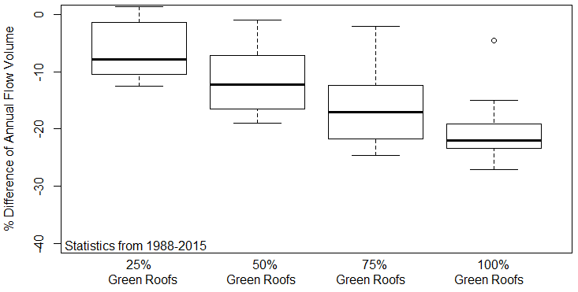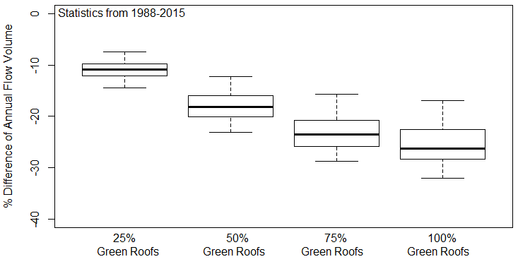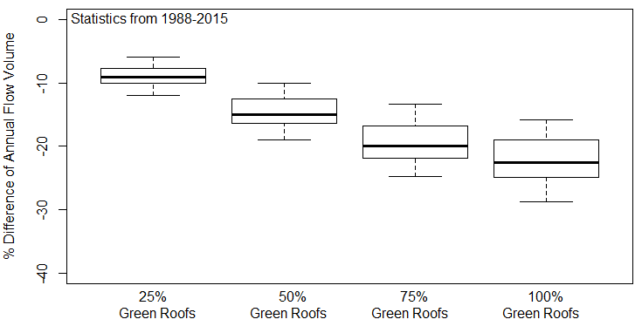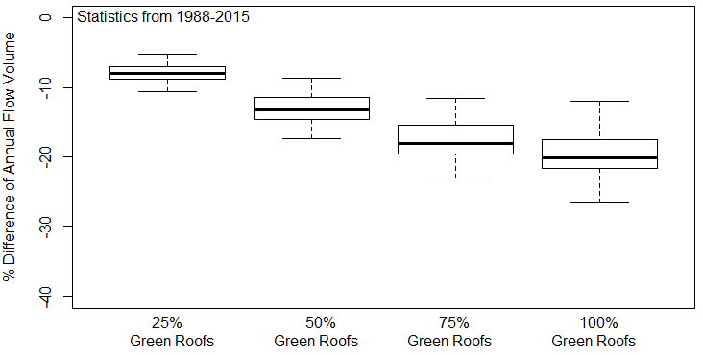

Longfellow

Taylor

Pipers

Thornton

**<Insert Figure 6 Here // Extensive Green Roof Reductions. >**

**Figure 6.** Percentage differences between the annual flow volume for the baseline simulations and the four scenarios of green roof implementations (25%, 50%, 75%, 100%) for the extensive green roof simulations. Simulations were run for 29 years (1987-2015), and the first year was a spin-up year and was not included in the results. The boxplots show the annual statistical variations.

**Conclusions**

We examined the hydrologic impacts of large-scale green roof implementations in four heavily urbanized watersheds in Seattle, Washington. We found that 30% and 15% median annual flow volume reductions were achievable when all of the buildings within the watersheds were converted to green roofs when using intensive and extensive green roof varieties, respectively. The land use percentages were remarkably similar among the four watersheds, even though the watersheds varied in size from 3 to 31 km2 and were located in the four corners of the Seattle metropolitan area. For all watersheds, approximately 10% of the watershed area comprised of buildings on which we ran our hypothetical green roof simulations. Therefore, by implementing green roofs in only 10% of the watershed area, we were able to obtain 30% reductions in the annual flow volume using extensive green roofs. This result should be encouraging for city planners who seek to mitigate excessive stormwater runoff in highly urbanized watersheds.

While we investigated a number of interesting scenarios using our gridded watershed model, we randomly distributed the green roofs throughout the watershed. One of the advantages of using spatially explicit (i.e., gridded) watershed models is the ability to test spatially precise implementations of green infrastructure and management. Therefore, future research should investigate the impacts of different spatial configurations of green roofs to determine whether prioritizing particular watershed areas can increase their effectiveness.

Further work could also compare the results of these scenarios to other hydrologic and watershed models (e.g., SWMM or WWHM).

**References**

ESRI 2014. ArcGIS Desktop: Release 10.3 Redlands, CA: Environmental Systems Research Institute.

Hufkens et al. (2018). An integrated phenology modelling framework in R: modelling vegetation phenology with phenor Methods in Ecology & Evolution, 9(2), 1-10

National Oceanic and Atmospheric Administration. Global Historical Climatology Network (GHCN). Retrieved on 12/8/2016 from: https://www.ncdc.noaa.gov/data-access

Python Software Foundation (2016). Python (Version 2.7.12) Beaverton, Oregon, USA. Retrieved from: http://www.python.org/

R Core Team (2014). R: A language and environment for statistical computing. R Foundation for Statistical Computing, Vienna, Austria. URL <http://www.R-project.org/>

Soil Survey Staff. Gridded Soil Survey Geographic (gSSURGO) Database for Washington state (2018). United States Department of Agriculture, Natural Resources Conservation Service. Available online at https://gdg.sc.egov.usda.gov/

Thornton, P.E., M.M. Thornton, B.W. Mayer, Y. Wei, R. Devarakonda, R.S. Vose, and R.B. Cook. 2018. Daymet: Daily Surface Weather Data on a 1-km Grid for North America, Version 3. ORNL DAAC, Oak Ridge, Tennessee, USA. https://doi.org/10.3334/ORNLDAAC/1328

Need Citation. http://www.seattle.gov/util/EnvironmentConservation/Projects/GreenStormwaterInfrastructure/CompletedGSIProjects/HighPointNaturalDrainageSystem/index.htm.

Need Citation. EPA 2018 City Green: Innovative Green Infrastructure Solutions for Downtowns and Infill Locations. 2016. EPA 230R16001. https://www.epa.gov/sites/production/files/2016-06/documents/city_green_0.pdf

Outline

1. Abstract
2. Introduction
   1. Seattle and its stormwater background.
   2. Green infrastructure for slowing and reducing stormflow.
   3. Goals of this work
      1. Adequately represent urban watersheds to simulate discharge using VELMA.
      2. Run 3 scenarios of alternative green infrastructure implementations by converting actual rooftops to include green roofs.
3. Methodology
   1. Site Overview: 4 watersheds in Seattle. Pipers, Longfellow, Taylor, and Thornton Creek.
   2. Model Overview Spatially Explicit VELMA
      1. Input Data: DEM, Cover, Soil
      2. Rain and Temperature Data: Point Locations
      3. Observed Discharge Data.
   3. Scenario Analysis Setup
      1. Current-day simulation for calibration
      2. 25%, 50%, 75%, 100% of roofs become green roofs.
4. Results
   1. Calibration Results
      1. Annual, Monthly, Daily Comparisons
      2. NSE, RSR, PBIAS for monthly estimates
   2. Scenario Results
      1. Reductions in Discharge (mm/day) for All 4 Scenarios (Plot with all watersheds and all 4 scenarios).
5. Discussion and Conclusions
   1. Able to represent urban systems using a spatially explicit model.
   2. Ultimately, chance for reductions are much lower in Pipers, which is highly forested already. However, there is higher possibilities in thornton.
   3. Future Work
      1. Inclusion of additional green infrastructure implementations (permeable pavement, roadside natural embankments to filter water).
      2. Couple an in-stream model (WASP) with VELMA to simulate impacts of urban stream restoration.